Day3 Task: To create VM in an Availability set and Creating disk and spinning up new VM using snapshot of the disk and Creating New VM using sysprep by the image

Created VM by name RakeshVM

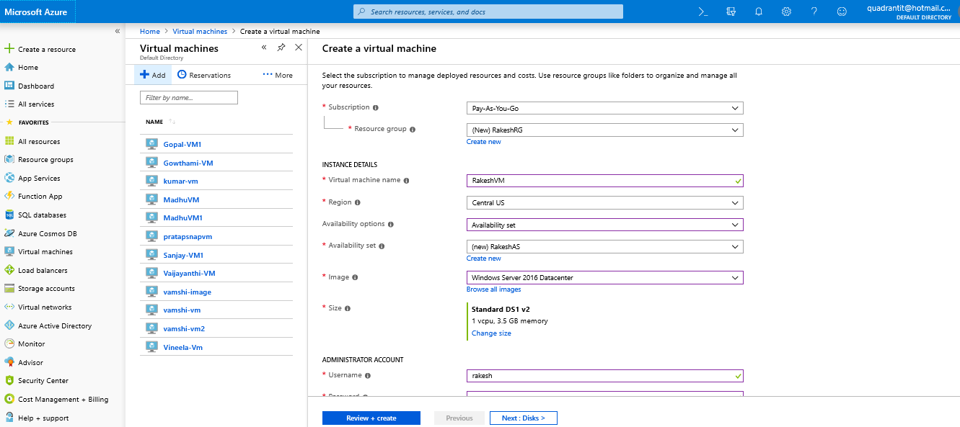

Created Availability set by name RakeshAS

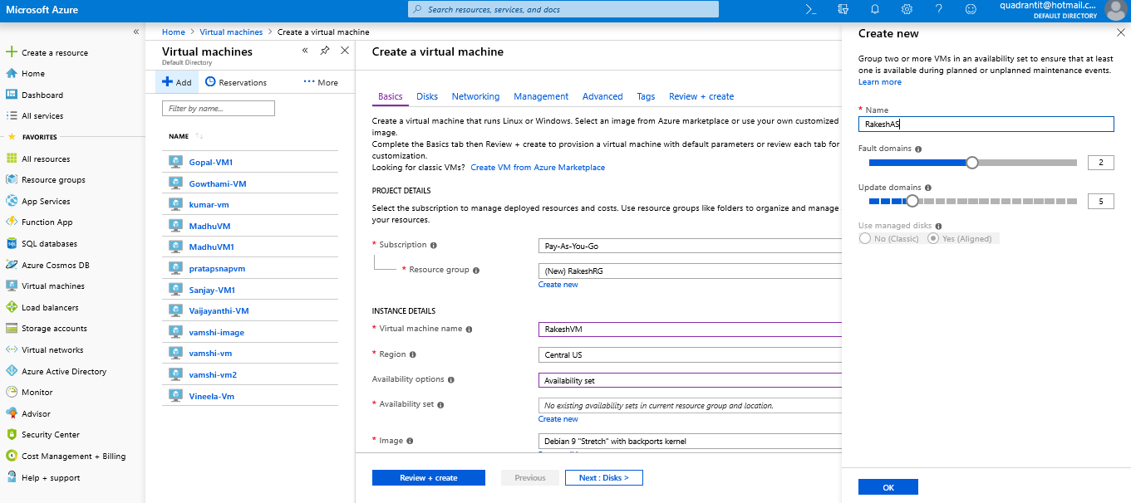

Added extension Antimalware

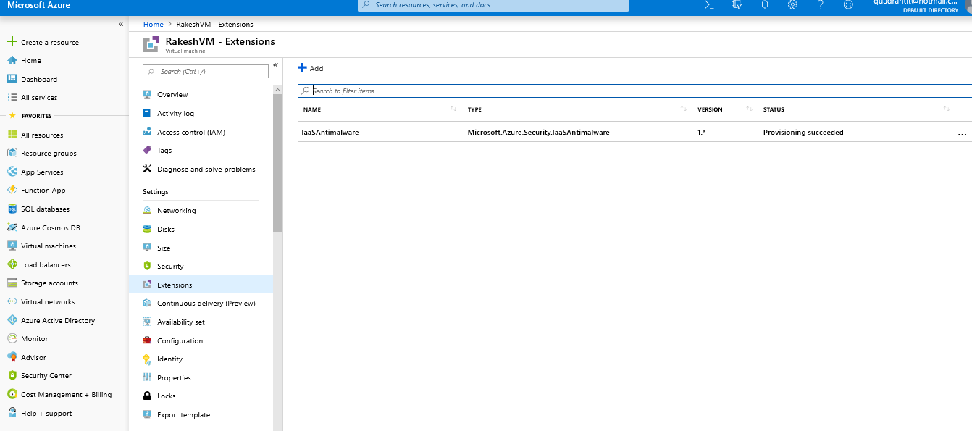

Created a new Data disk

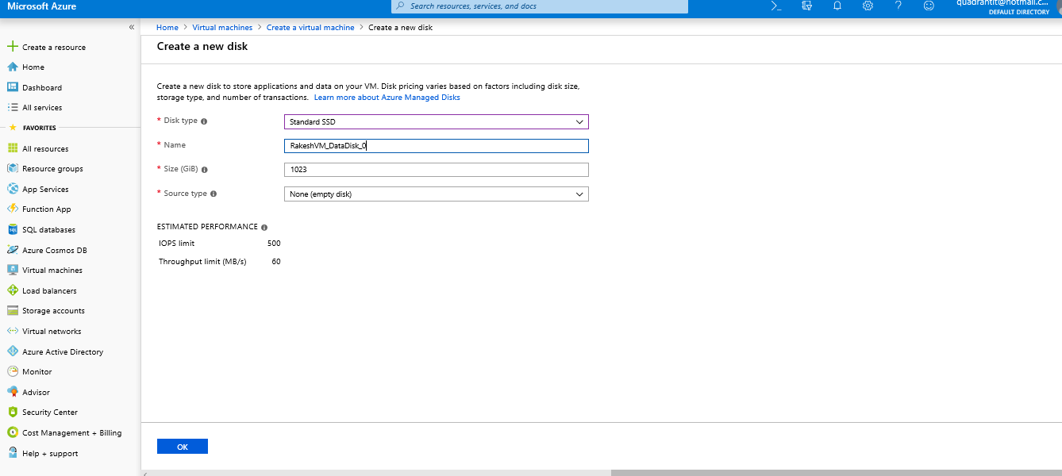

Created snapshot of the Disk

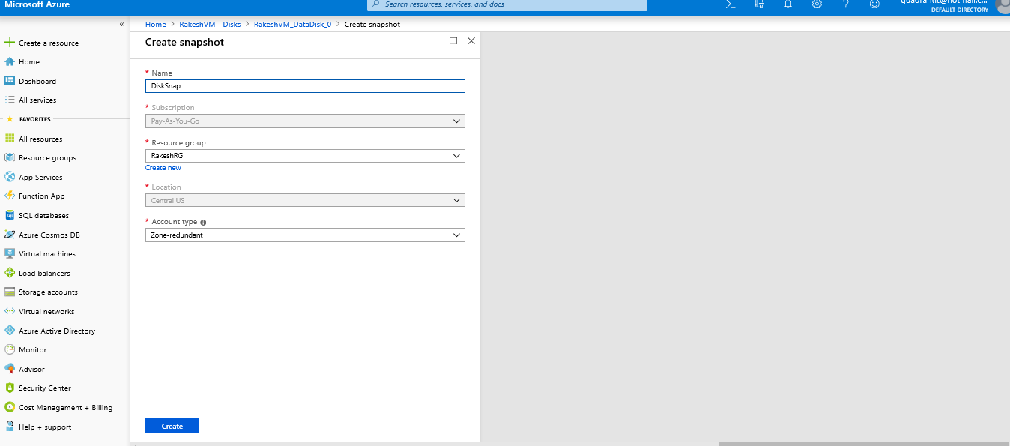

Resource Group with all Resources in it

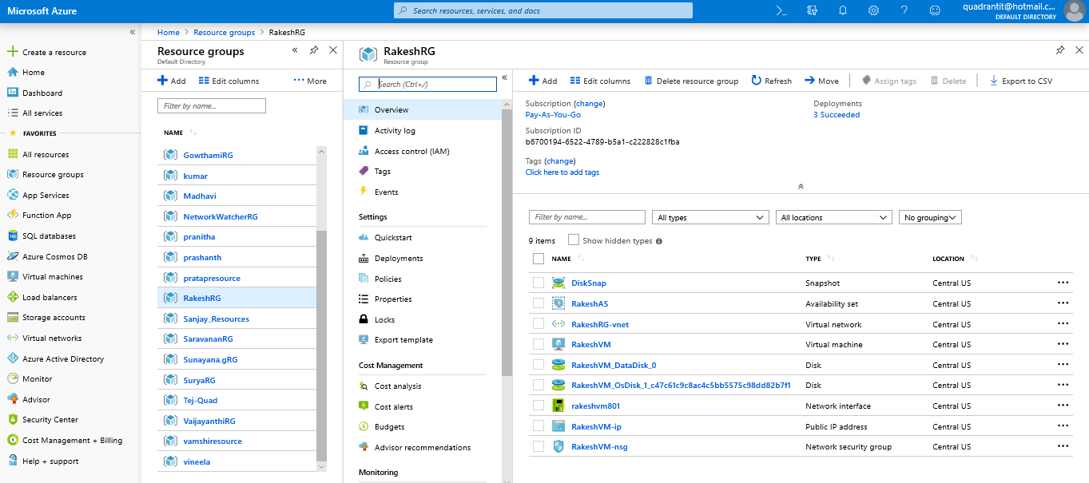

Connected to RDP

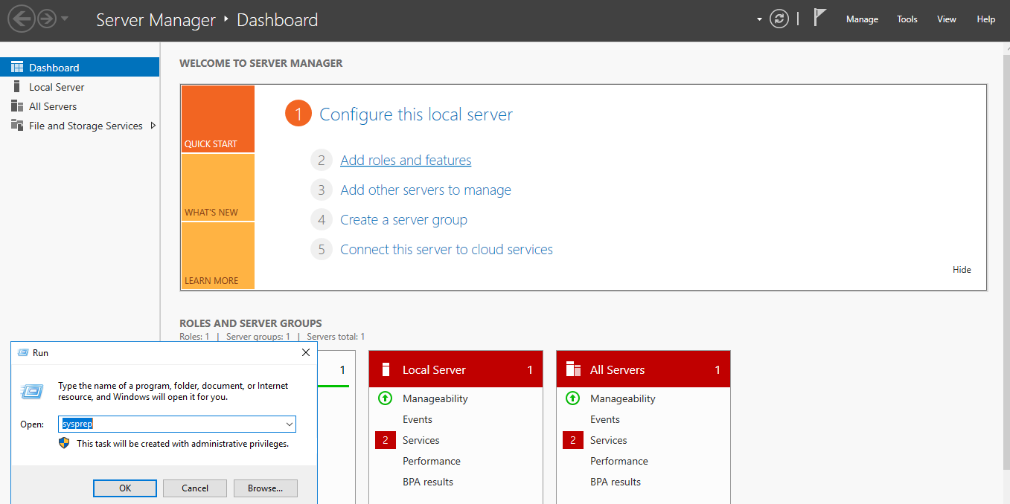

Enabling Sysprep

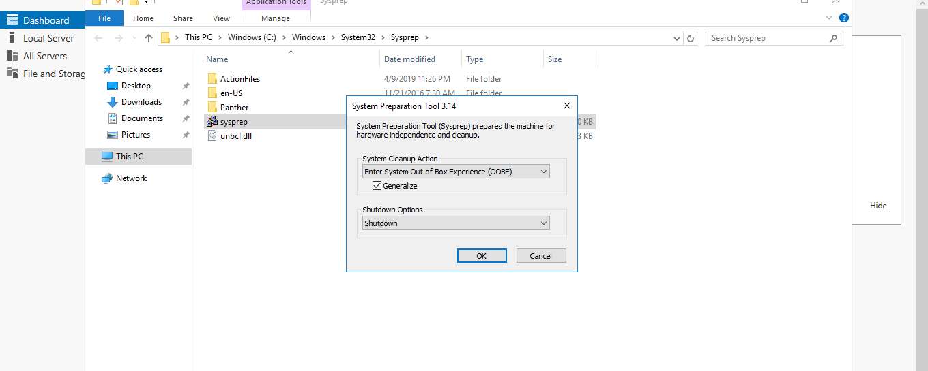

Creating Image with the sysprep(Capture)

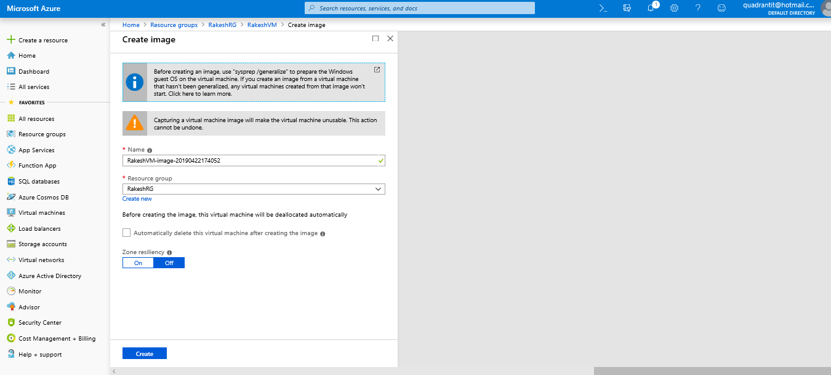

Creating another VM using Image

